Online Vehicle Parking Reservation System

ABSTRACT
The increased number of vehicles in a high-density population area is an issue especially when these areas are unorganized in terms of vehicle parking facilities. Having good automated road management and smart parking reservation systems can help to decrease traffic congestion, fuel consumption, and save the driver's time. This paper introduces the concept of an Online Vehicle Parking Reservation System to design and implement a real-time parking management solution. The proposed system offers a web-based platform where administrators manage parking slots, and users can book and release slots in real-time. It automates the parking process through digital booking, time-based cost calculation, and secure payment functionality. The proposed system has also taken into consideration the authentication issue to prevent unauthorized parking and ensure a seamless and efficient user experience.

Keywords:
Online Vehicle Parking, Smart Parking System, Real-Time Booking, Web-Based Application, Parking Slot Management, Digital Payment, Traffic Congestion Reduction, Automated Parking, Authentication, Urban Mobility Management.

EXISTING SYSTEM:
In the existing parking systems, users often rely on manual methods such as physical tokens, on-site payments, or paper-based bookings. These methods are time-consuming, lack real-time updates, and are prone to human errors, leading to inefficiencies and user dissatisfaction.
Disadvantages
- Manual slot allocation leads to errors and confusion.
- No real-time status tracking of parking availability.
- Inefficient billing system with no time-based cost calculation.

PROPOSED SYSTEM:
The proposed online vehicle parking reservation system offers a web-based platform where admins manage parking slots, and users can book and release slots in real-time. It automates the parking process with digital booking, time-based cost calculation, and payment functionality for a seamless user experience.
Advantages
- Real-time slot booking and availability tracking.
- Automated cost calculation based on parking duration.
- User-friendly interface with digital booking, payment, and history tracking.

Modules Description:
To implement this project, we have designed following modules
- Admin Login: Allows the administrator to log in using predefined credentials to manage the parking system.
- Add Parking Area: Enables the admin to add new parking locations and define the number of slots available in each area.
- Modify Parking Area: Provides functionality for the admin to edit existing parking details such as slot availability and parking cost.
- View Users: Displays a list of all registered users who have signed up in the system.
- View Occupancy: Shows the admin a real-time status of all occupied and available slots across different parking areas.
- User Sign Up: Allows new users to register by entering their personal details to gain access to the system features.
- User Login: Enables registered users to log in and access the parking reservation features.
- Book Slot: Users can browse through available parking areas and book a specific slot in a desired location.
- Release Slot: Lets users release their booked slot; the system automatically calculates the parking duration and cost, and simulates a payment process.
- View History: Users can check their past parking transactions including slot IDs, timings, and payment details.

SYSTEM ARCHITECTURE:

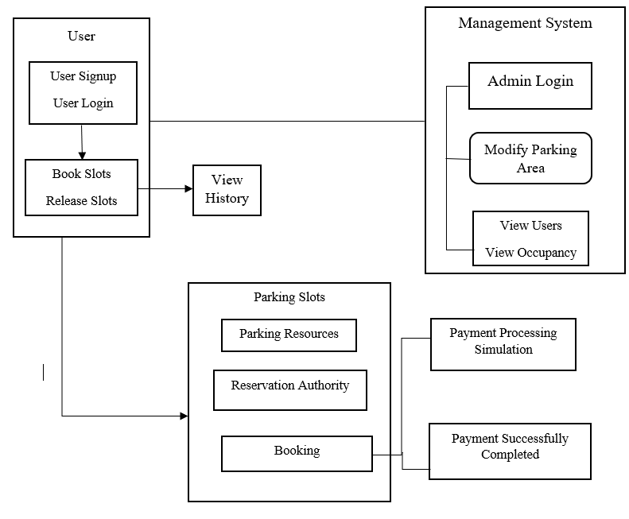
SYSTEM REQUIREMENT:
HARDWARE REQUIREMENTS:

Processor - Intel I3(min)
- Speed - 1.1 GHz
- RAM - 4GB (min)
- Hard Disk - 500GB (min)
SOFTWARE REQUIREMENTS:
- Operating System - Windows 10/above
- Programming Language - Python 3.7.2 with Django

